**Nama Anggota : - Muhammad Fadhil Ihsan (1301170505) : No 1 & 3**

**- Adam Syahputra (130117) : No 2**

**- Alfiansyah (130117) : No 2**

**- Muhammad Khaifa Gifari (1301170382) No 1 & 3**

1. **A. Serial**

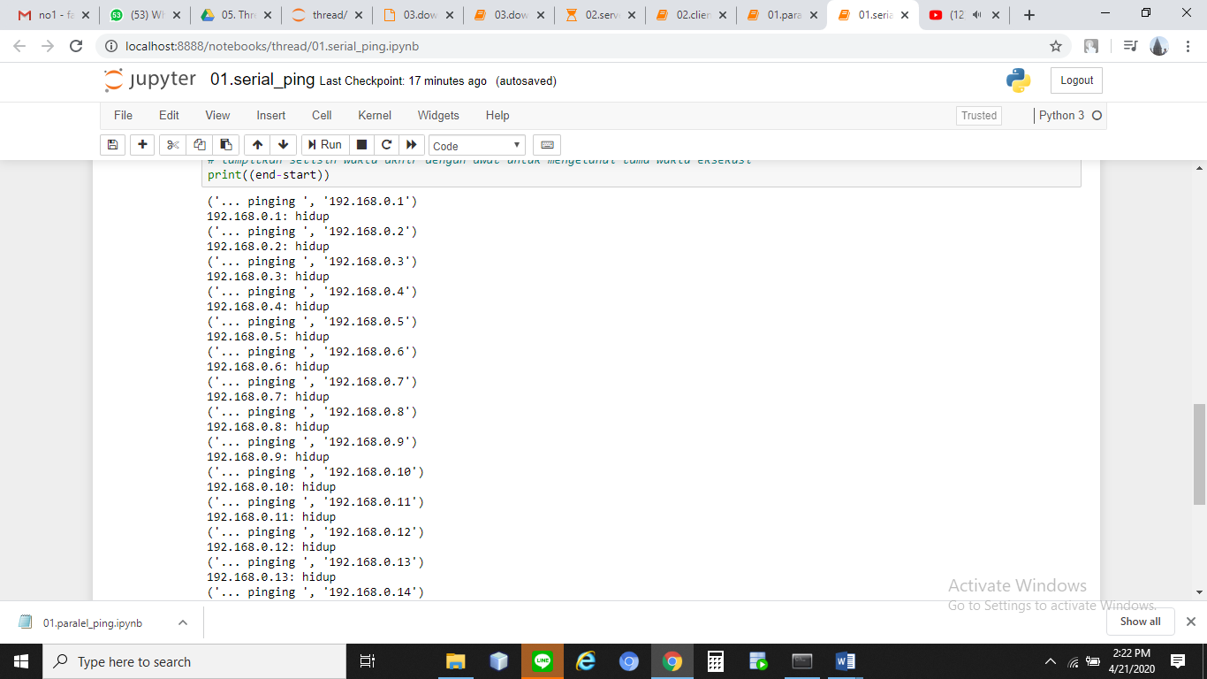

**B.Paralel**

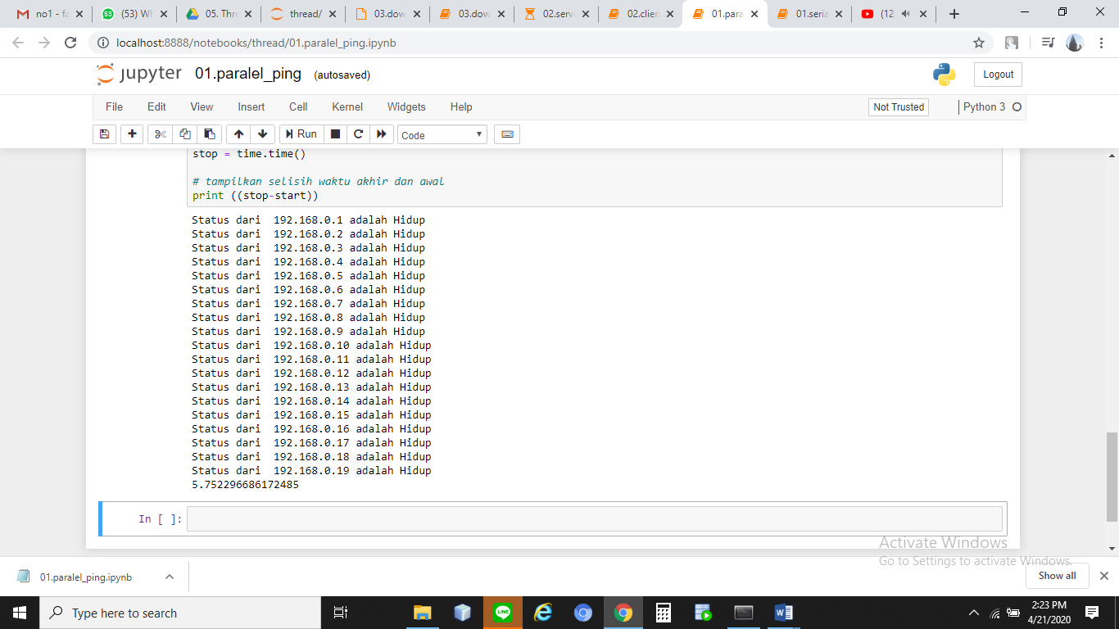

1. **Server_thread**

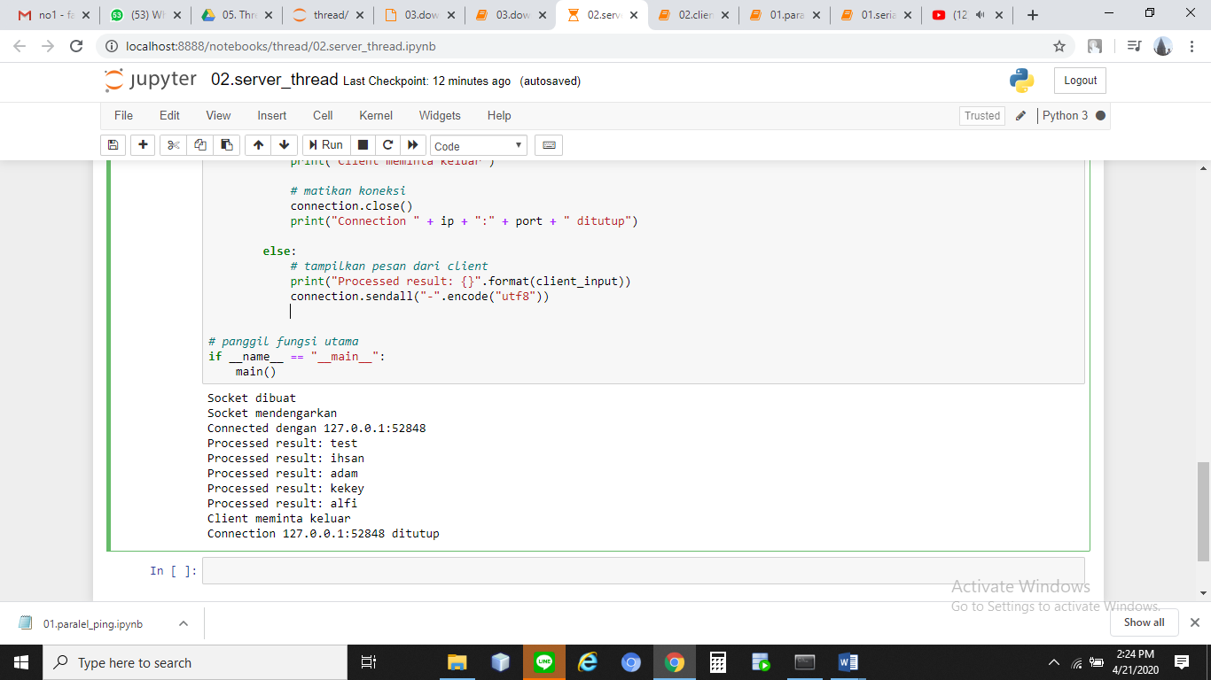

**Client_thread**

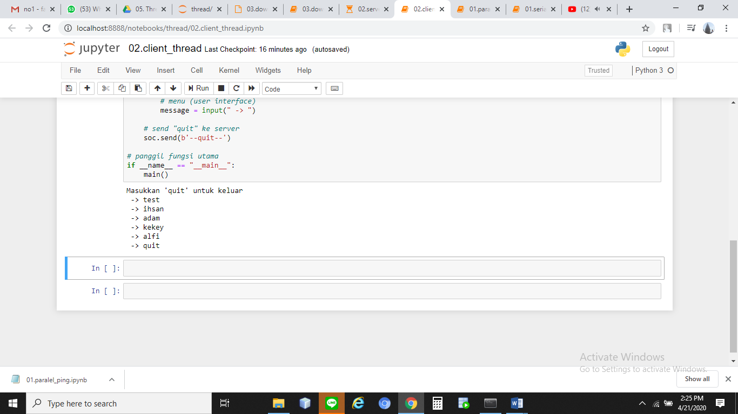

1. **Download File**

